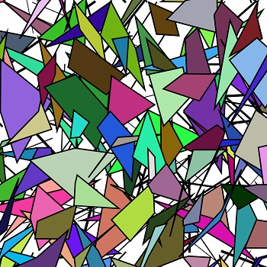

Maret Baer - T2_Garment

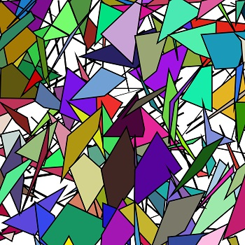

Maret Baer - T3_Garment

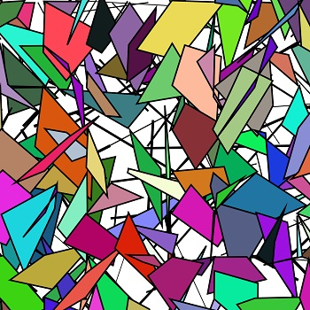

Maret Baer - T4 Avatar and Dress_V3

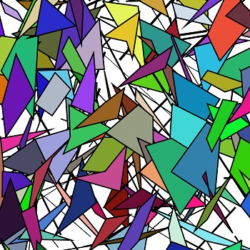

Maret Baer - T4_Avatar and Dress Catwalk

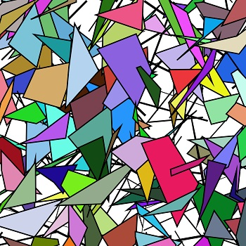

Maret Baer - T6_Garment_Jumpsuit